Applet in Java
- Applet is a Java program that runs in a java compatible Web browser like Internet Explorer or Netscape Navigator.
- Applets are Java program but they reside on server.
- Applet can’t be executed like standalone application.
- Applets are designed to be embedded within an HTML page.
- When a user views an HTML page that contains an applet, the code for the applet is downloaded to the user's machine.
- A JVM is required to view an applet.
- JVM creates an instance of the applet class and invokes init() method to initialize an Applet.

Differences between Applet and a standalone Java application
Application | Applet
1. It has main() method. | It has no main() method.
2. Applications are used only for standalone machine or local area network. | Applet programs are used on internet.
3. In application we can access system resources. | In applet can’t access system resources.
4. Applications are stored in hard-disk of local machine. | Applets are stored in a server.

The hierarchy of the Applet
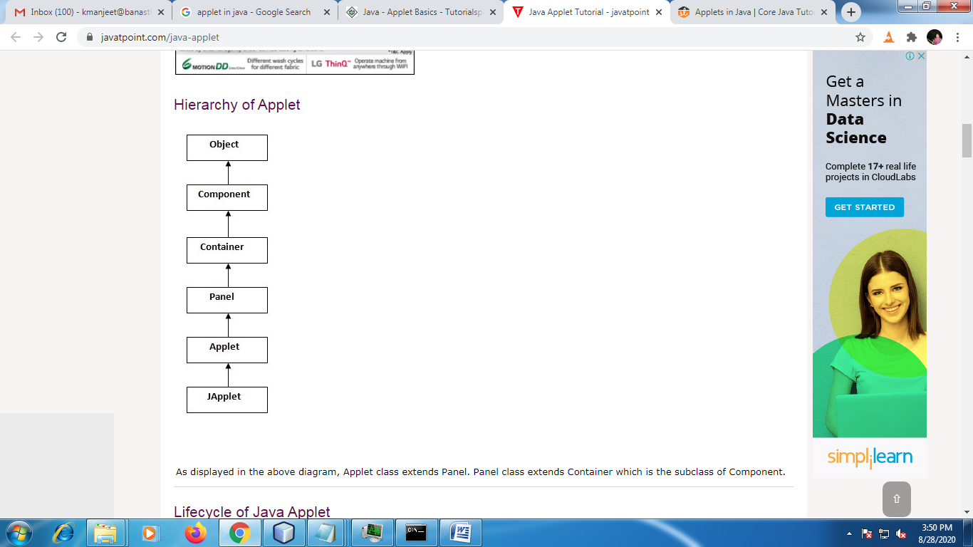
Here you can see Applet class extends Panel. Panel class extends Container which is the subclass of Component.

Writing an Applet
import java.awt.*;
import java.applet.*;
public class AppletLogin extends Applet{
Label lbluid,lblpwd;
TextField txtuid,txtpwd;
Button btnLogin;
Panel p1;
public void init()
{
lbluid=new Label("Enter the User ID:");
lblpwd=new Label("Enter the Password:");
txtuid=new TextField(20);
txtpwd=new TextField(20);
btnLogin=new Button("Login");
p1=new Panel();
add(p1);
p1.add(lbluid);p1.add(txtuid);
p1.add(lblpwd);p1.add(txtpwd);

p1.add(btnLogin);
}
}

- Every Applet application must import two packages - java.awt and java.applet.
- The Applet class is contained in the package “java.applet”.
- To create an applet, a class must class extends Applet class.
- Applet class provides all necessary support for Applet execution such as starting and stopping applet.
- Applet class provides necessary support for all the window based activities.
- The class in Applet program must be declared as public because its object is created by Java Plug-in software that resides on the browser.
- While writing the applet code we normally override some of the methods of Applet class, which are invoked automatically during applet execution.
- It is very common to override the paint() method. The code in the paint() method mainly display the output in the Applet area/window.

Life cycle of Applet
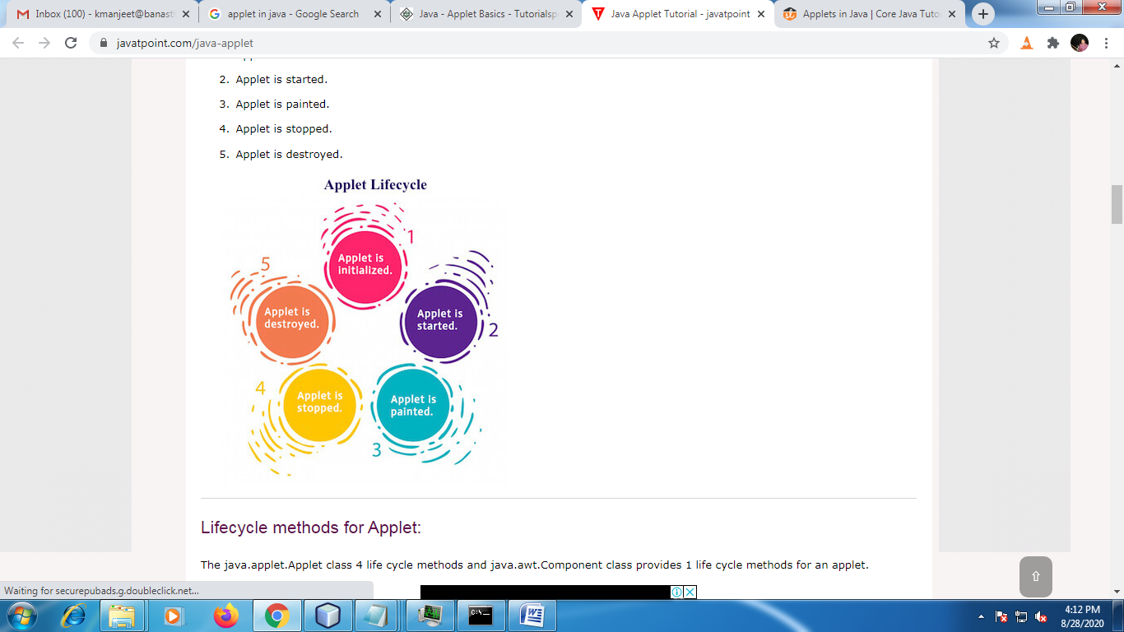
- public void init(): is used to initialized the Applet. It is invoked only once.
- public void start(): is invoked immediately after the init() method or browser is maximized. It is used to start the Applet.
- public void stop(): is used to stop the Applet. It is invoked when Applet is stop or browser is minimized.
- public void destroy(): is used to destroy the Applet means when you close the Applet. It is invoked only once.
- public void paint(Graphics g): is used to paint the Applet. It provides Graphics class object that can be used for drawing oval, rectangle, arc etc.
How to run an Applet?
There are two ways to run an applet
- By html file.
- By appletViewer tool.
- By html file
create an Applet program then save and compile it. After that create an html file and place the applet code in html file.
Eg:
Save file with name: AppletLogin.java
Compile : javac AppletLogin.java

AppletLogin.html
<html>
<body>
<applet code=" AppletLogin.class" width="300" height="300">
</applet>
</body>
</html>

Run:
d:\>appletviewer DemoApplet.html
- By appletViewer tool.
To execute the applet by appletviewer tool, create an applet that contains applet tag in comment and compile it. (Note: applet tag loads the Applet class)
/* <applet code=" AppletLogin.class" width="300" height="300"> </applet> */
import java.awt.*;
import java.applet.*;
public class AppletLogin extends Applet{
Label lbluid,lblpwd;
TextField txtuid,txtpwd;
Button btnLogin;
Panel p1;
public void init()
{
lbluid=new Label("Enter the User ID:");
lblpwd=new Label("Enter the Password:");
txtuid=new TextField(20);
txtpwd=new TextField(20);
btnLogin=new Button("Login");
p1=new Panel();
add(p1);
p1.add(lbluid);p1.add(txtuid);
p1.add(lblpwd);p1.add(txtpwd);

p1.add(btnLogin);
}
}
Compile:
d:\>javac DemoApplet.java
Run:
d:\>appletviewer DemoApplet.java

Drawing in an Applet Area
To draw the different shapes such as Oval, Rectangle, Arc etc or display string in applet area, we need to override paint() method in our program. The paint() method takes the parameter as an object of Graphics class. Graphics class contains method to draw the different shapes in applet area such as Oval, Rectangle, Arc etc.

/*<applet code="DemoApplet.class" height=400 width=500></applet>*/
import java.awt.*;
import java.applet.*;
public class DemoApplet extends Applet{
public void paint(Graphics g)
{
g.drawString("Manjeet",100,50);
}
}
Compile:
d:\>javac DemoApplet.java
Run:
d:\>appletviewer DemoApplet.java

Predefined methods available in Graphics class are:
Sr.  No. | Methods | Description
1 | public abstract void drawString(String str, int x, int y) | Used to draw specified string.
2 | public void drawRect(int x, int y, int width, int height) | Used to draw a rectangle of specified width and height.
3 | public abstract void fillRect(int x, int y, int width, int height) | Used to draw a rectangle with a default colourof specified width and height.
4 | public abstract void drawOval(int x, int y, int width, int height) | Used to draw oval of specified width and height.
5 | public abstract void fillOval(int x, int y, int width, int height) | Used to draw oval with a default colour of specified width and height.
6 | public abstract void drawLine(int x1, int y1, int x2, int y2) | Used for drawing lines between the point (x1, x1) and (x2, y2).
7 | public abstract booleandrawImage(Image img, int x, int y, ImageObserver observer) | Used for drawing a specified image.
8 | public abstract void drawArc(int x, int y, int width, int height, intstartAngle, intarcAngle) | Used for drawing a circular arc.
9 | public abstract void fillArc(int x, int y, int width, int height, int startAngle, int arcAngle) | Used for filling circular arc.
10 | public abstract void setColor(Color c) | Used to set a colour to the object.
11 | public abstract void setFont(Font font) | Used to set font.

Eg:
/*<applet code=" GraphicsDemo.class" height=400 width=500></applet>*/

import java.applet.Applet;
import java.awt.*;
public class GraphicsDemo extends Applet
{
public void paint(Graphics g)
{
g.setColor(Color.black);
g.drawString("Welcome to Banasthali",50, 50);
g.setColor(Color.blue);
g.fillOval(170,200,30,30);
g.drawArc(90,150,30,30,30,270);
g.fillArc(270,150,30,30,0,180);
g.drawLine(21,31,20,300);
g.drawRect(70,100,30,30);
g.fillRect(170,100,30,30);
g.drawOval(70,200,30,30);
}
}

Q: Draw smiley in Applet.
/*<applet code=" GraphicsDemo.class" height=400 width=500></applet>*/

import java.applet.Applet;
import java.awt.*;
public class GraphicsDemo extends Applet
{
public void paint(Graphics g)
{
Font f=new Font(“Arial”,Font.BOLD,30);
g.setFont(f);
g.drawString(“Keep Smiling !”,50,30);
g.drawOval(60,60,200,200);
g.fillOval(90,120,50,20);
g.fillOval(190,120,50,20);
g.drawLine(165,125,165,175);
g.drawArc(110,130,95,95,0,-180);

}
}
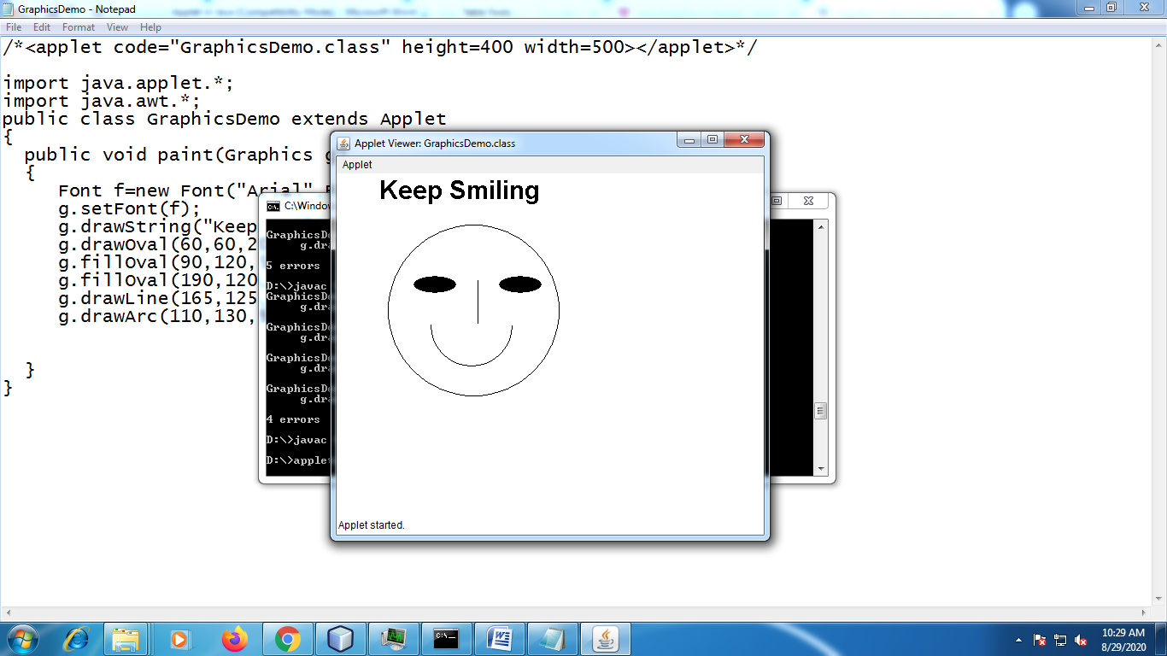
Passing parameters to Applet
You can pass the parameter to the applet through HTML file. Parameters are passed to applet in name and value pairs in <param> tag between the opening and closing applet tags.
Inside the applet, you read the values passed through the <param> tag with getParameter() method of Applet class.
Syntax:
public String getParameter(String parameterName);

Q: Write a Java program in Applet to pass your name through HTML file to the applet. Display your name in Applet area.
/*<applet code="MyApplet.class" height=400 width=500>
<param name="s1" value="manjeet">
</applet>
*/
import java.applet.*;
import java.awt.*;
public class MyApplet extends Applet
{
String s;
public void init()
{
s=getParameter("s1"); //get the value passed through param tags
}
public void paint(Graphics g)
{
g.setColor(Color.red);
g.drawString(s,100,100);
}
}

Q: Write a Java program in Applet to pass your name and font size through HTML file. Display your name with the given font size in applet area.
/*<applet code="MyApplet.class" height=400 width=500>
<param name="s1" value="manjeet">
<param name="s2" value="30">
</applet>
*/
import java.applet.*;
import java.awt.*;
public class MyApplet extends Applet
{
String name,fontSize;
public void init()
{
name=getParameter("s1"); //get the value passed through param tags
fontSize=getParameter("s2");
}
public void paint(Graphics g)
{
int fs=Integer.parseInt(fontSize);
Font f=new Font("Times New Roman",Font.BOLD,fs);
g.setFont(f);
g.drawString(name,100,100);
}
}

